_________________________________________________________________

Epoch 1/100

163/163 [==============================] - 55s 325ms/step - loss: 0.3683 - accuracy: 0.8240 - val_loss: 0.2277 - val_accuracy: 0.8970 - lr: 0.0010

Epoch 2/100

163/163 [==============================] - 52s 321ms/step - loss: 0.2168 - accuracy: 0.8989 - val_loss: 0.2136 - val_accuracy: 0.9055 - lr: 0.0010

Epoch 3/100

163/163 [==============================] - 53s 323ms/step - loss: 0.1511 - accuracy: 0.9356 - val_loss: 0.2117 - val_accuracy: 0.9131 - lr: 0.0010

Epoch 4/100

163/163 [==============================] - 53s 325ms/step - loss: 0.1085 - accuracy: 0.9564 - val_loss: 0.1816 - val_accuracy: 0.9208 - lr: 0.0010

Epoch 5/100

163/163 [==============================] - 54s 332ms/step - loss: 0.0784 - accuracy: 0.9683 - val_loss: 0.2380 - val_accuracy: 0.9147 - lr: 0.0010

Epoch 6/100

163/163 [==============================] - 54s 329ms/step - loss: 0.0495 - accuracy: 0.9817 - val_loss: 0.2305 - val_accuracy: 0.9285 - lr: 0.0010

Epoch 7/100

163/163 [==============================] - 53s 326ms/step - loss: 0.0469 - accuracy: 0.9835 - val_loss: 0.2031 - val_accuracy: 0.9308 - lr: 0.0010

Epoch 8/100

163/163 [==============================] - 53s 326ms/step - loss: 0.0190 - accuracy: 0.9942 - val_loss: 0.2247 - val_accuracy: 0.9293 - lr: 1.0000e-04

Epoch 9/100

163/163 [==============================] - 53s 325ms/step - loss: 0.0158 - accuracy: 0.9954 - val_loss: 0.2481 - val_accuracy: 0.9270 - lr: 1.0000e-04

INFO:tensorflow:Assets written to: /content/drive/MyDrive/CTProposedSplit0.8noAug9000/assets

Test Loss: 0.20684

Test Accuracy: 92.62%

/usr/local/lib/python3.7/dist-packages/ipykernel_launcher.py:133: DeprecationWarning: `np.int` is a deprecated alias for the builtin `int`. To silence this warning, use `int` by itself. Doing this will not modify any behavior and is safe. When replacing `np.int`, you may wish to use e.g. `np.int64` or `np.int32` to specify the precision. If you wish to review your current use, check the release note link for additional information.

Deprecated in NumPy 1.20; for more details and guidance: <https://numpy.org/devdocs/release/1.20.0-notes.html#deprecations>

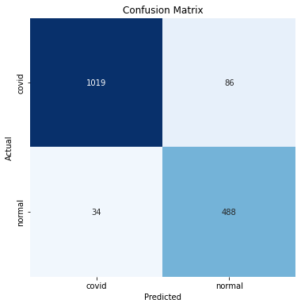

Classification Report:

----------------------

precision recall f1-score support

covid 0.97 0.92 0.94 1105

normal 0.85 0.93 0.89 522

accuracy 0.93 1627

macro avg 0.91 0.93 0.92 1627

weighted avg 0.93 0.93 0.93 1627

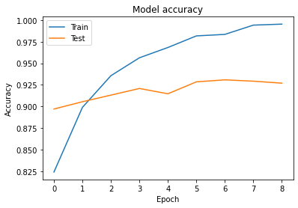

<matplotlib.legend.Legend at 0x7f874d67cf50>

